**CAR AUTOMATION SYSTEM – DATA FLOW DIAGRAM**

**Context Diagram**

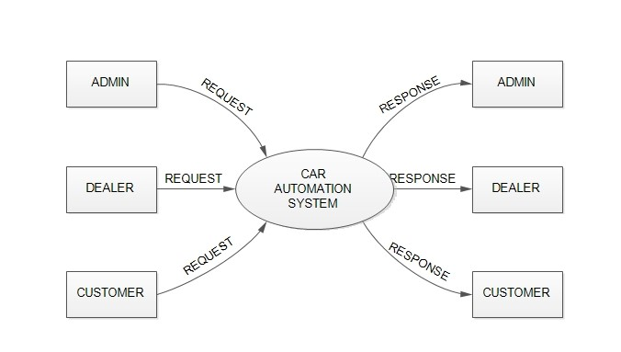

**First Level DFD for Admin**

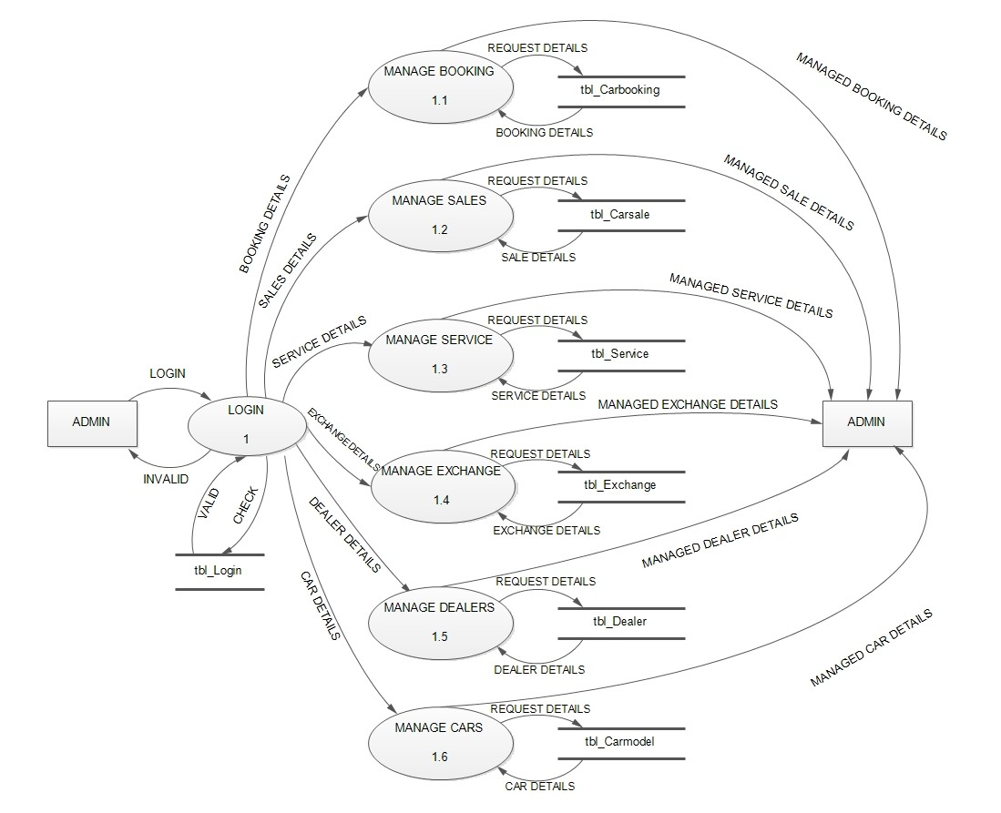

**First Level DFD for Dealer**

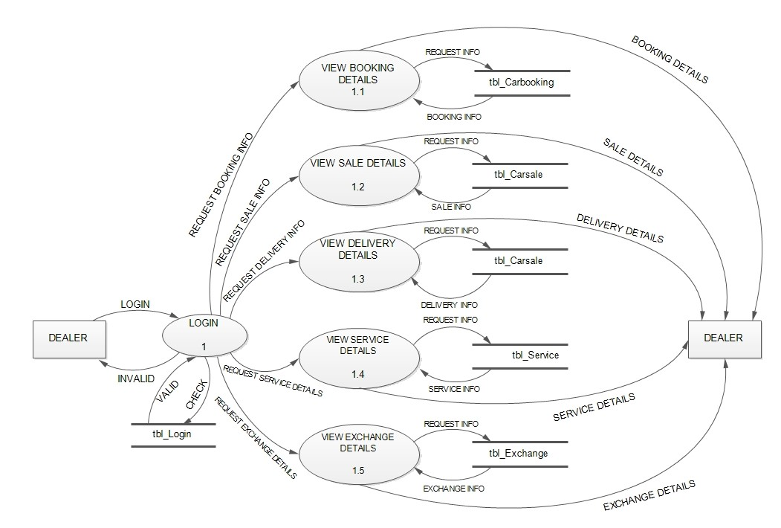

**First Level DFD for Customer**

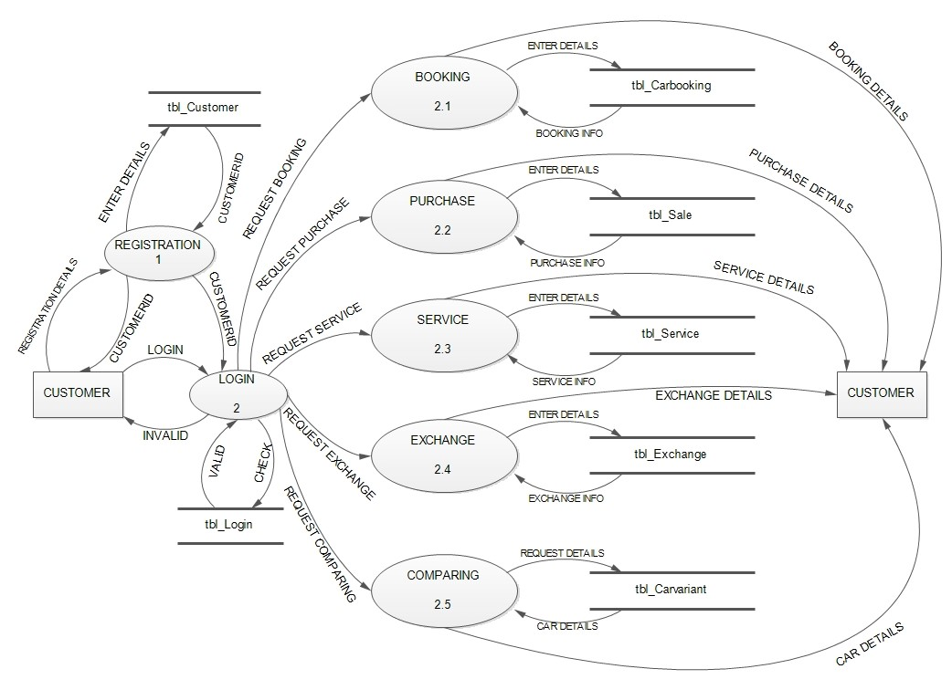

**Second Level DFD for Customer**

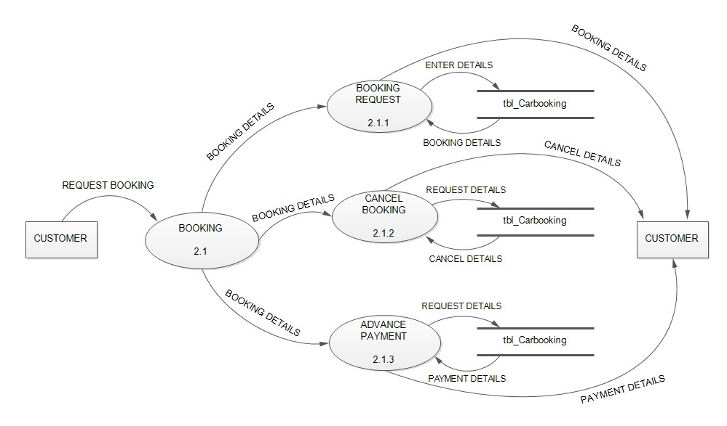

**Second Level DFD for Customer**

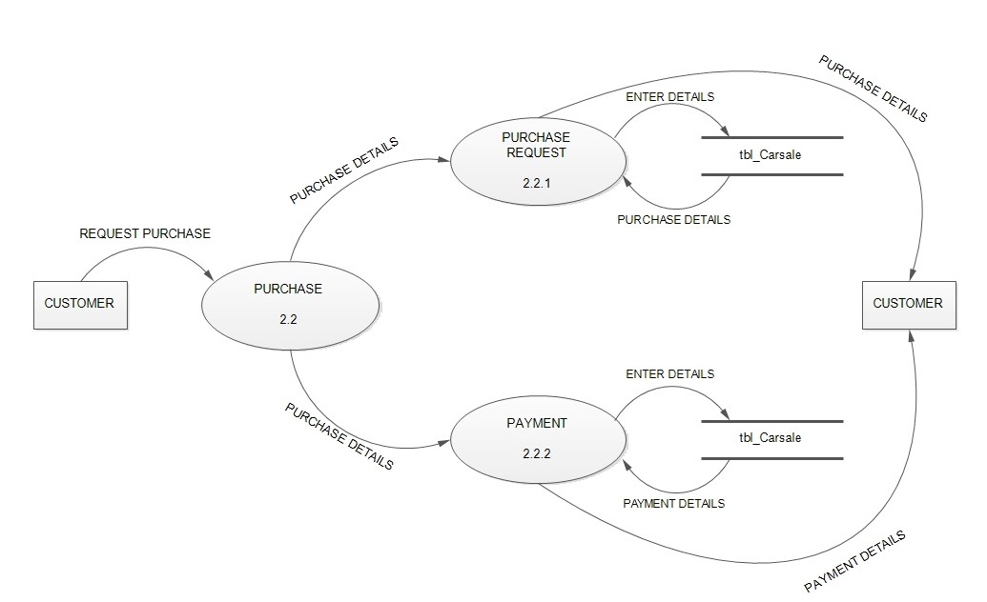

**Second Level DFD for Customer**

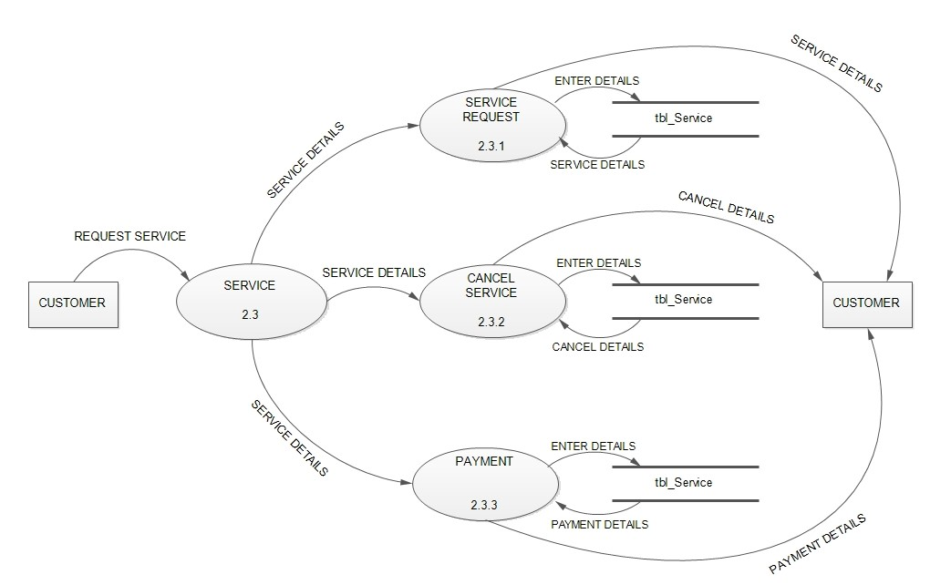

**Second Level DFD for Customer**

